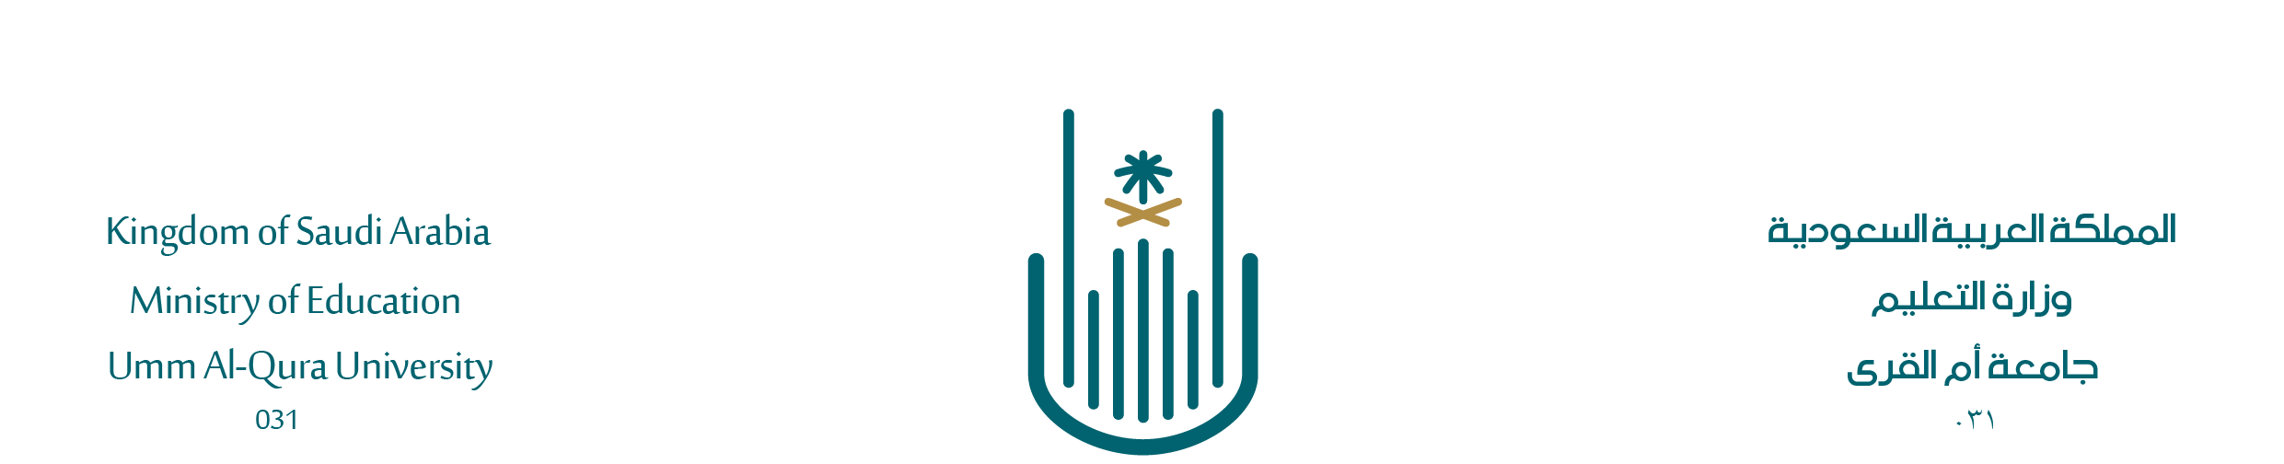

Report on the Compliance of a Course Exam with Testing Standards

First: Basic information:
University | ......................................................................
College | ......................................................................
Students | Males |  |  | Females
Department/
Program
Study level | Intermediate Diploma | Bachelor |  | Higher diploma |  | Master’s |  | Ph.D.
Academic year | ..........14 / ...........14
Semester | First |  | Second |  |  |  | Third
Course Name and Code | ........................ Course Name |  |  |  | Course Code ………………………
Exam Preparer’s Name, Degree, and Specialization | Name degree …………………………………………………………  Degree ………………………………………………………….……  General Specialization ……………………………………………….  Specific Specialization ………………………………………………
Report Preparer’s Name, Degree, and Specialization | Name degree …………………………………………………………  Degree ………………………………………………………….……  General Specialization ……………………………………………….  Specific Specialization ………………………………………………
Second: Results of the Exam Review:

1. In Terms of Form and Wording:
Basic Information | Met |  |  | Not Met |  |  |  |  |  | Notes
Formatting | Good | Adequate |  |  |  |  | Needs change
Printing | Clear | Adequate |  |  |  |  | Not clear
Wording | Clear and Unambiguous |  |  |  |  | Allows for Different Interpretations
Spelling Errors | None |  | Few |  |  |  |  | Many
Grade Distribution | Present |  |  |  |  | Not present

2. In Terms of Content:
- Comprehensiveness: (The extent to which the questions cover all the course topics and target learning outcomes)
Comprehensive (70% or more) |  | Somewhat Comprehensive |  |  |  |  |  |  | Not Comprehensive
- Objectivity: (Measures the targeted learning outcomes and requires specific answers that can be evaluated)
Questions have specific answers related to the curriculum |  |  |  |  | There are questions without specific answers not related to the curriculum
- Variety: (Variety in question types between objective and essay or, if entirely objective, between fill-in-the-blank, multiple-choice, matching, and true/false questions)
Highly Varied  (3 or more types) |  | Somewhat Varied  (2 types) |  |  |  |  |  |  | Not Varied  (1 type)
- Discrimination: (Considers individual differences among students and distinguishes between levels of achievement, i.e., weak, average, and outstanding students)
Fully Discriminates |  | Somewhat Discriminates |  |  |  |  |  |  | Does Not Discriminate
- Compliance with the Test Specifications Table:

Compliant |  | Somewhat Compliant |  |  |  |  |  |  | Not Compliant
Approved By
Head of Department
Name ……………………..……..

Signature ……………………….
Report Preparer

Name ……………………..……..

Signature ……………………….

- An attachment of the test specifications table for the course by the teaching faculty member is required.
- An attachment of a table showing the question numbers related to each course outcome is required.

Course Outcome Code | Related Exam Question Numbers |  |  |  |  |  |  |  |  | Total Marks for Outcome
1-1
1-2
2-1
2-2
2-3
2-4
3-1
3-2

